Graph: Pie, Bar or Line
Create a graph that represents a significant idea/data about Mesopotamia in the time period we are studying (2300 B.C.E. – 539 B.C.E.).
*Graph may be hand-drawn
*Create a Graph On Line ( http://nces.ed.gov/nceskids/createagraph/default.aspx )
Plan Your Content Here:

Criteria:
- graph is appropriately titled.
- key is accurate
- correct number of categories to represent data
- categories/axes are correctly labeled
- categories are correctly apportioned with percentages to represent data (pie)
- bars are spaced properly (bar)
- data displayed at equal intervals on both axes (bar and line)
- accurate display of data
- color is used in a meaningful way
- graph is centered or placed appropriately on the page
- graph is constructed neatly/writing is legible

Infographic
Create an infographic that represents a significant idea/data about Mesopotamia in the time period we are studying (2300 B.C.E. – 539 B.C.E.).

*Infographic may be hand-drawn
*Create an Infographic on your computer

Plan Your Content Here:

Criteria:

Map

Using the outline map provided, create a full color map of all 4 Empires mentioned in Chapter 6 of your History Alive! textbook.
Label all relevant parts of your map and give your map a title.
Be sure to provide a key and make sure all labels are legible and correctly spelled.
Color code and label the locations and years of the following Empires:
- Akkadian Empire
- Babylonian Empire
- Assyrian Empire
- Neo-Babylonian Empire

Label all:
- Significant landforms
  - Arabian Peninsula
  - Zagros Mountains
  - Taurus Mountains

- Bodies of water
  - Caspian Sea
  - Mediterranean Sea
  - Red Sea
  - Persian Gulf
  - Tigris River
  - Euphrates River

Suggested presentation: Create an “Old Paper Look”
Stain the paper you plan to create your final map on by dipping the paper into a tray filled with brewed black tea (Earl Grey works well.) Allow the paper to absorb the tea for 5-7 minutes in the tray. Then carefully remove the paper; it will be wet, and may tear easily. Dry the paper completely (recommend several days before you want to write on the paper).

Venn Diagram
Create a Venn Diagram that compares and contrasts 2 significant Empires from Mesopotamia in the time period we are studying (2300 B.C.E. – 539 B.C.E.).

*Diagram may be hand-drawn.
*Create a Venn Diagram Online:
http://www.readwritethink.org/files/resources/interactives/venn/index.html

Which two Empires will you be comparing and contrasting?
- Akkadian Empire
- Babylonian Empire
- Assyrian Empire
- Neo-Babylonian Empire

Plan Your Content Here:
Empire 1Only | Both Empire 1 and 2 | Empire 2 Only
1 | 1 | 1
2 | 2 | 2
3 | 3 | 3
4 |  | 4
5 |  | 5

Criteria:
- at least 5 facts about each individual Empire are included
- at least 3 similarities of the two Empires are included
- all statements noting similarities are placed in the center of the circles
- all statements that note differences are placed in the correct outer circle
- all statements are supported by the text
- color is used in a meaningful way
- graph is centered or placed appropriately on the 8.5” by 11” page
- graph is constructed neatly/writing is legible

Illustrated Timeline
Create a timeline of what you believe to be the 5 most important events for 1 of the 4 Empires: Akkadian Empire, Babylonian Empire, Assyrian Empire, or Neo-Babylonian Empire. Each event must occur in order on a timeline that considers the scale of time between events as well as an illustration that represents the event.
Please include a sentence that justifies the significance of each event you chose to include. In other words, why do you think this event was important then or now?
Write legibly or type.
Example:

1750
1760  1763 | Picture to show this event  Proclamation of 1763: This act placed restrictions on the areas where colonists could live; attempting to avoid any further costly wars, or conflicts with Native Americans, the British declared that the land won during the French and Indian war west of the Appalachian Mountains would be reserved for Native Americans.
1770

Postcard
Imagine you are a tourist visiting Mesopotamia in a time B.C.E.; write a postcard home describing the region to your friends and family.

Design the front of your postcard with a full color picture that represents the region.

Write the rough draft of your letter below.
Be sure to include at least 5 fun facts about the region.
Design a cool stamp!
Date________________________
Dear ________________________,

Sincerely,
Your Name

Ask a friend to proofread your 1st Draft before creating your final draft on a large index card so you have no spelling or grammatical errors. Pay close attention to tricky spellings of Mesopotamian place names! Look them up in your book if you are unsure.

Text Message

Imagine you are a citizen of Mesopotamia in a time B.C.E. observing a major event in the history of your Empire; write a text message to your best friend giving your eyewitness account of the event.
Write the rough draft of your text below.
Be sure to include at least 5 facts about the event and
how you feel about what you are witnessing.

Ask a friend to proofread your 1st Draft before creating your final draft on a large index card so you have no spelling or grammatical errors. You may use texting shorthand where appropriate. (OMG!) Pay close attention to tricky spellings of Mesopotamian place names! Look them up in your book if you are unsure.

Diary Entry
Imagine you are a citizen of Mesopotamia in a time B.C.E. Choose to be a member of the upper class, lower class, slave or priest of the Empire; write a diary entry describing a typical day in your life.
Write the rough draft of your text below.
Be sure to include at least 5 facts about your social class and
how you feel about the class of which you are a part.

Ask a friend to proofread your 1st Draft before creating your final draft on a large index card so you have no spelling or grammatical errors. Pay close attention to tricky spellings of Mesopotamian words! Look them up in your book if you are unsure.

Comic Strip

Create a comic strip that tells the story of an important event, person or innovation in one of the four Mesopotamian Empires.

Use these cells to plan your comic strip.
Criteria:
- Your comic strip must have at least 3 cells
- Your final draft should be on a sheet of unlined paper at least 8.5” by 11”
- Your comic should have a balance of words and illustrations
- All artwork must be neat and all writing must be legible
- Proofread your work so you have no spelling or grammatical errors
- Check tricky spellings of Mesopotamian names
- The final product should be in color

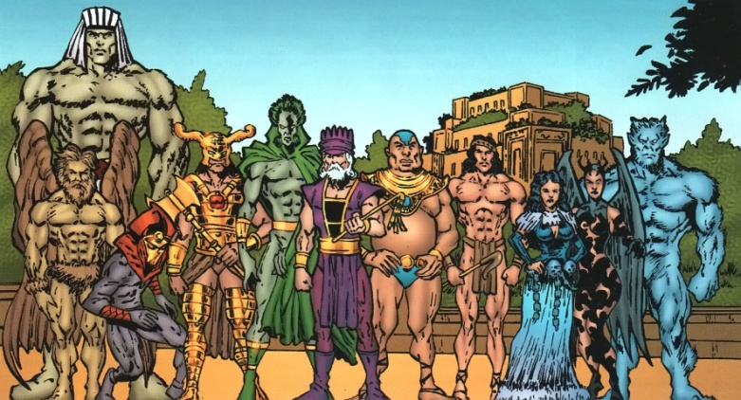

Menu

Imagine you are a citizen of Mesopotamia in a time B.C.E. planning to open a restaurant in your Empire; do some research and create a menu featuring foods and dishes that would be available in this region during the time period.

Plan your menu here:
Restaurant Name
__________________________________________________
Owner (That’s You!)
__________________________________________________

Not only must your menu feature real foods from Mesopotamia, but you should also make them as appetizing as possible to your customers. Include mouth-watering descriptions and illustrations and proofread carefully. Your final draft should be on paper that is at least 8.5” by 11” and should look like a menu you might find in a restaurant. Make sure it is neat and legible.

Want Ad
Imagine you are an upper class citizen of Mesopotamia in a time B.C.E. planning to hire a lower class citizen to work for you as a personal laborer; create a want ad to recruit potential employees from your region during the time period.
First, look at some employment ads in the newspaper or online so you get a feel for the format.
Plan your want ad here:
Help Wanted
Upper class Mesopotamian seeks day laborer for the following position:

Position Title

Job Summary

Duties and Responsibilities

Qualifications

Benefits

Send completed application and resume to

Ask a friend to proofread your 1st Draft before creating your final draft so you have no spelling or grammatical errors. You may use advertising shorthand where appropriate. Pay close attention to tricky spellings of Mesopotamian place names! Look them up in your book if you are unsure. Make your ad look like it could have come right out of a Mesopotamian newspaper.

Trading Cards
Create 4 trading cards, 1 for a person from each of the 4 Empires: Akkadian Empire, Babylonian Empire, Assyrian Empire, and Neo-Babylonian Empire.
Cards should be at least 3” by 5”, like a standard notecard. Each card should have a color picture and information on both sides. Information should include three interesting facts about the subject, as well as his impact on history and the world we live in today. Write legibly.
Planning for your Trading Cards
Leader | Facts (3) | Impact

Front Back
All About____________________________

Interesting facts:
*

*

*
Impact on history:

Why we remember ____________today:

Name

Picture

Battle:

Scrapbook of Civilization

Create a scrapbook documenting the life of a family living in one of the four Empires: Akkadian Empire, Babylonian Empire, Assyrian Empire, or Neo-Babylonian Empire.
Your scrapbook will use words and images to present the 8 essentials of civilization (cities, religion, social classes, art & architecture, organized central government, job specialization, written language, and public works) through the eyes of one family.
Criteria:
- cover includes title, author’s name, is colorful and creative with picture related to the book
- minimum length= cover + 8 pages
- all pages contain neat, detailed, creative and colorful graphics related to the content
- every page has captions that are relevant and explanatory
- relates 8 essentials to family’s personal life
- pictures, photo- graphs, drawings, diagrams, graphs, or other similar devices add to the overall effectiveness of the scrapbook
- there is a wholeness about the scrapbook; the theme is consistent throughout

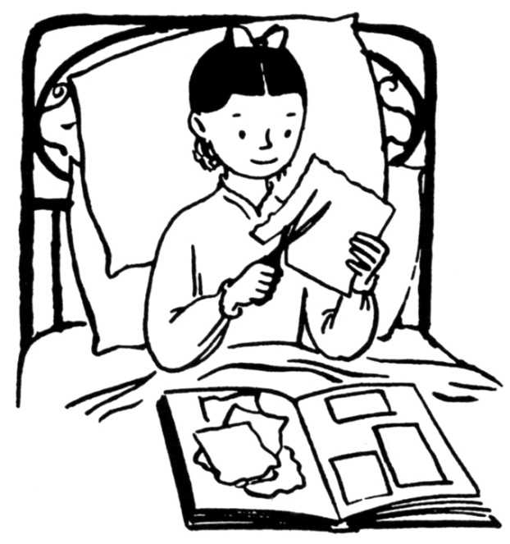

Music Video/
Live Performance of Original Song

Compose and present an original song to the class on a topic of your choice from Mesopotamian history. You may perform your song in front of the class or use one of several electronic formats to record a music video.

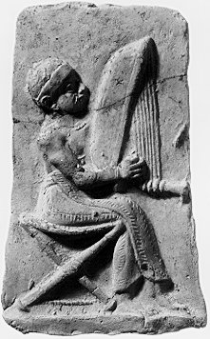

Criteria:

- lyrics must be appropriate and make sense
- written copy of lyrics must be submitted prior to presentation
- lyrics may be set to a previously written tune
- song length: 2 minutes
- sound quality counts; if we can’t hear it, we can’t learn from it

Game of Daily Life

Everyone has played the game of LIFE, but you are going to create a game on daily life in Mesopotamia during the time period we are studying.
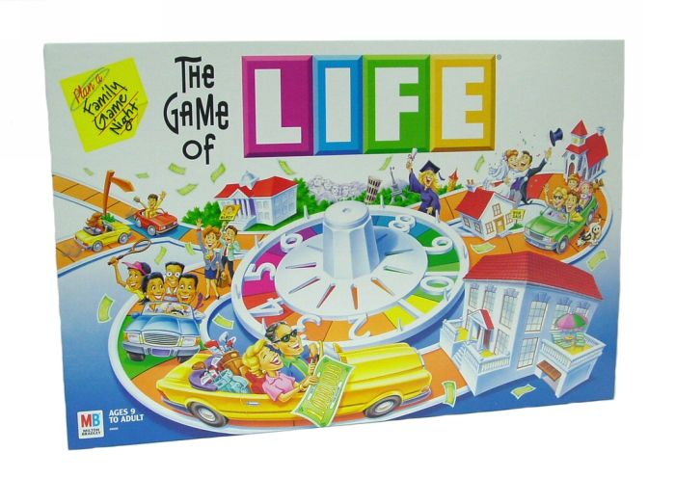

Criteria:
- include a complete set of rules for playing the game
- at least 4 thematic game pieces for players
- at least 25 colored thematic squares
- at least 20 questions/activity cards
- include a thematic title on the board
- game board should be at least the size of an open file folder
- include all necessary equipment (dice, spinner, etc.)
- game must be FUN!

Podcast

Interview
(Live or Taped)

If you ever dreamed of being Oprah Winfrey or Jay Leno, this project is for you! You are going to have your own show on which you will interview a Mesopotamian from the period we are studying.

Criteria:
- you must have at least 8 prepared questions relevant to the person you choose to interview and the time/place studied
- you must also make sure that the answers are prepared in advance to demonstrate expertise on this culture
- sound quality counts; if we can’t hear it, we can’t learn from it
- use creativity to make it entertaining for the audience

Travel Agent

Create a slideshow or video you could use as a travel agent to entice tourists to visit your Mesopotamia in the B.C.E. era.

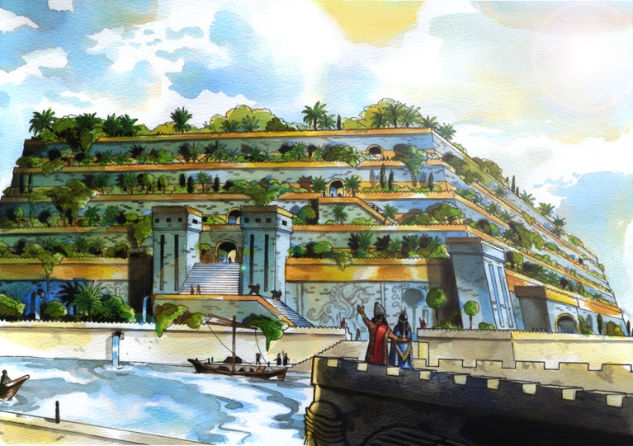

Criteria:
- use a story board to plan out your presentation; this will be submitted
- at least 10 slides or two minutes of video presentation
- images should outweigh words on presentation, but you may fill with prepared travel talk
- slides should be in color and have no more than one graphic per slide
- if animation or music is used, it must make sense in the context of the material and not distract from it
- presentation should be practiced and flow smoothly

